

Asset Practice Answers: Science

**1. Two vessels are connected as shown below. First, when the tap is closed, only one of them has water.**

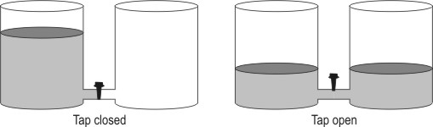**After the tap is opened, there is water in both the vessels.**

**What can we say about the total amount of water after opening the tap? A. It is the same because no water has been poured in or out at all.**

**B.** It is more because now there is water in both the vessels.

**C.** It is less because the height of the water in the vessels has come down.

**D.** We cannot say anything without measuring the amounts of water in both cases.

**2. Study the figure given below. Which of the blocks shown is the heaviest?**

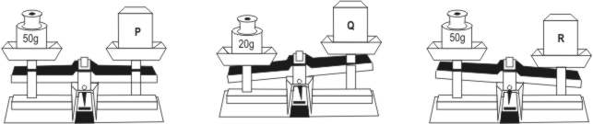

**A.** P

**B.** Q

**C. R**

**D.** Can’t determine

**3. Based on who eats whom, the organisms can be arranged in a particular order. For example, in the image below, a deer eats grass and a tiger eats deer.**



**In which of the following are the organisms arranged correctly in this order?**

**A.** **Frog -> Snake -> Owl**

**B.** Wolf -> Rabbit -> Lion

**C.** Cat -> Mouse -> Spider

**D.** Snake -> Rat -> Peacock

**4. Priyam found a bird that**

**• eats grains and cooked food.**

**• avoids hawks and falcons, as it is the food for them.**

**• prefers narrow sheltered spaces for nesting, as it does not build a big nest.**

**The home of this bird is most likely to be __________.**

**A.** on a high branch of a tree that is open to the sky

**B.** on the soft sand beside a pond

**C.** in an isolated cave in the forest

**D. on a hidden window sill of a building**

**5. The spines of a porcupine serve the same purpose as the _________.**

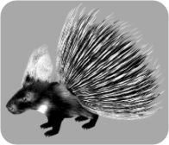

**A.** mane of a lion

**B.** feathers of a peacock

**C. fur of a polar bear**

**D.** shell of a tortoise

**6. Here are some properties of an object:**

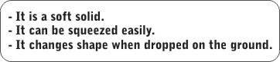

**A.** A pillow

**B.** A cube of ice

**C.** A glass bottle

**D. A lump of wet clay**

**7. The following words are used to describe different substances. Materials that can be stretched into wires are called DUCTILE. Materials that break easily are called BRITTLE. Materials that are soft and can be beaten into sheets are called MALLEABLE. Shyam dropped his ice-cream cup and it broke into pieces because it was __________.**

**A.** malleable

**B.** ductile

**C. brittle**

**D.** all of the above

**8. Prabha puts a thermometer in a beaker with cold water.**

**The mercury level gives the temperature of the water. What will happen to the mercury level in the thermometer if she takes it out of a beaker of cold water and puts it in a beaker of hot water?**

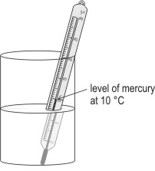

**A. It will rise.**

**B.** It will fall down.

**C.** It will remain at the same place.

**D.** It will change only if the water is boiling.

**9. Shown here is a label found on a strip of tablets. Which of the circled areas indicates the amount of medicine present in one tablet?**

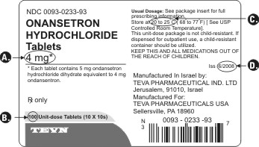

**Correct Answer: A**

**10. What could be the use of the instrument shown here?**

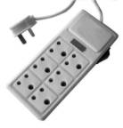

**A.** To heat water, as an electric heater.

**B.** As a remote control for toy cars.

**C.** As a battery for some types of toys.

**D. To provide power to more than 1 device.**

**11. Malini has lost her bicycle key and wants to use a car key to unlock her bicycle. Her father tells her that she cannot unlock the bicycle with the car key because it is different in some ways. Which of these differences do not allow the car key to unlock the bicycle?**

**A. Its size and shape.**

**B.** Its size and colour.

**C.** Its shape and weight.

**D.** Its shape and material.

**12. Neeta's fingers got burnt when she touched a hot vessel by mistake. What should she do**

**IMMEDIATELY?**

**A.** Tie a handkerchief tightly around her fingers.

**B. Keep the burnt fingers under running water.**

**C.** Apply an ointment and keep rubbing her fingers.

**D.** Do nothing till the doctor comes.



**Science**

1. A: When the tap between the two vessels is opened, water flows from one vessel to the other. Has any water been removed from the vessels? No, it hasn't. No water has been added to them either. Water has only flowed from one vessel to the other. This means that the amount of water has remained the same. It has not been changed at all. Thus, only option A is correct. We can say this without measuring, so option D is incorrect.

2. C: In the 1st figure, the scale is balanced, so P weighs 50 g. In the 2nd figure, we see that Q is lighter than 20 g and in the 3rd figure, we see that R is heavier than 50 g. This means that R is the heaviest of the 3 blocks. Hence, option C is the only correct answer.

3. A: We know that a deer eats grass and a tiger eats a deer. Look at the arrows in the question - they point from the food to the animal eating the food. Hence, option A is the only correct answer as it shows the proper arrows between animals. A frog is eaten by a snake, which is eaten by an owl. A cat is never eaten by a mouse and neither is a mouse usually eaten by a spider. Hence, option C is incorrect.

4. D: This bird is eaten by large birds like hawks and falcons. So, it wants to stay away from those birds. It likes making nests in small spaces that are covered and that can give shelter. This type of bird will NOT build a nest on the high branch of a tree that is open to the sky. Hence, option A is incorrect. It will build its nest somewhere hidden and where it can easily get cooked food and grains. Hence, it will build its nest in a small region where humans live, like the window sill of a building. Hence, option D is correct.

5. D: The spines of a porcupine are very sharp and can hurt animals that attack it. They protect the porcupine from its enemies. The mane of a lion, feathers of a peacock and the fur of a polar bear do not protect them from their enemies. The hard shell of a tortoise protects the animal from its enemies. Thus, it is the most similar to the spines of the porcupine. Hence, option D is the correct answer.

6. D: It is a soft solid, which means that it can be pressed. A glass bottle or a cube of ice is not soft and cannot be pressed easily. Hence, options B and C are incorrect. A pillow can be squeezed easily, but it does not change shape much when dropped on the ground. Only a lump of wet clay can be squeezed and changes shape when dropped on the ground. Thus, option D is the only correct answer.

7. C: In the question, we see that materials that break easily are brittle. Since the ice-cream cup broke into pieces, we can call it brittle. We cannot call it malleable because it is probably not soft and cannot be beaten into sheets. Thus, option C is the only correct answer.

8. A: Have you ever seen how a thermometer works? There is a small bulb at one end of the thermometer. It has a dark liquid in it called mercury. When the thermometer comes in contact with a hot object, this dark liquid moves up in the thermometer. The more it moves up, the hotter is the object. So the level of mercury will rise as it is put in a beaker with hot water. The water need not be boiling for the mercury to rise. Even if it is slightly hotter, the mercury level will rise.

9. A: Some medicines are strong and some medicines are very mild - this depends on the amount of medicine in each tablet. Ask your parents to show you the back of some medicines. The amount of medicines are usually shown in something called a 'milligram' which is shown as 'mg'. Option A shows this in the figure. Below it, you can also see some information about the amount of medicine in each tablet. Option B only shows the number of tablets in the packet, not the amount of medicine in each one. Hence, it is incorrect.

10. D: We have plug points in our house where we can plug a device that requires electricity. Sometimes in our house, in a room, we might find only one plug point but we may need to use more than 1 devices. Instruments, like the one shown in the image, can be used to plug in more than 1 devices and each one can be run on electricity. The instrument shown can be used to plug in an electric heater. It cannot be used directly as an electric heater.

11. A: Have you seen a key carefully? Take the key of your bicycle and the key of your parent's vehicle and check if they are same. If they are different, check what is different. You will find that the part of the key that goes into the keyhole has a particular shape and size. Different keys have different shapes and sizes and that is the reason why each lock can be opened by only one key. The keys can be made of the same material but their size and shape will mostly be different.

12. B: If you get burnt by touching a hot object, the first thing you should do is put the burnt part under running water. The part should not be rubbed or nothing should be applied immediately to it.